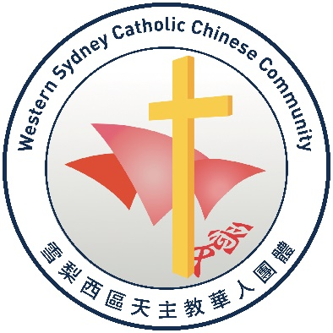

Consent Form: Children and Young People taking part in Ministry Activities

As a parent or guardian of a Child or Young Person who wishes to take part in Parish ministry activities, we kindly ask that you fill in the below consent form and return it to the Ministry Leader or Parish Priest in your Parish.

Ministry Details

Name of ministry: _____________________________________________________________

Frequency of attendance in ministry: ______________________________________________

Name of supervisor of ministry: __________________________________________________

Details of Child/Young Person

Name of Child/Young Person: ______________________________________________

Age of Child/Young Person: ________________________________________________

Details of any medical conditions or special needs: _______________________________

__________________________________________________________________

Child/Young Person’s Consent

I _______________________________ would like to take part in the ministry listed

above in the Parish of ___________________________________________________.

Child/Young Person’s signature: _____________________

Parent/ Guardian/Caregiver consent

I _______________________________consent to __________________________________

taking part in the ministry listed above in the Parish of ________________________________

Parent/guardian’s signature: __________________________________

Name: ___________________________________________

Date: ______________________

